**Problem Statement** :Making career choices and AI based counselling accessible to every child at secondary level along with aptitude tests and detailed career paths.

**Description**:We had established an interactive AI based model that will help students to choose from careers. The model would handhold student in assessing his capabilities and subsequently help him in deciding a career path.

**Idea/Approach Details:**

* Career Compass is a React-based platform designed to help students make informed decisions about their career paths.
* The heart of Career Compass is our time based aptitude tests carefully crafted to evaluate quant skills.
* Our TensorFlow based Chatbot takes the stage engaging users in a psychometric test to uncover their unique personality traits.
* By integration cutting edge ML models we match this personality traits to suitable career and degree programs.
* We provide the top 3 career choices based on user data along with the success trajectory of the career recommendations.
* We also provide contact information for experienced career counselors support for users to navigate their chosen path.

Features we have build here are :

1)Login page:Allow users to sign up and log in using their credentials.

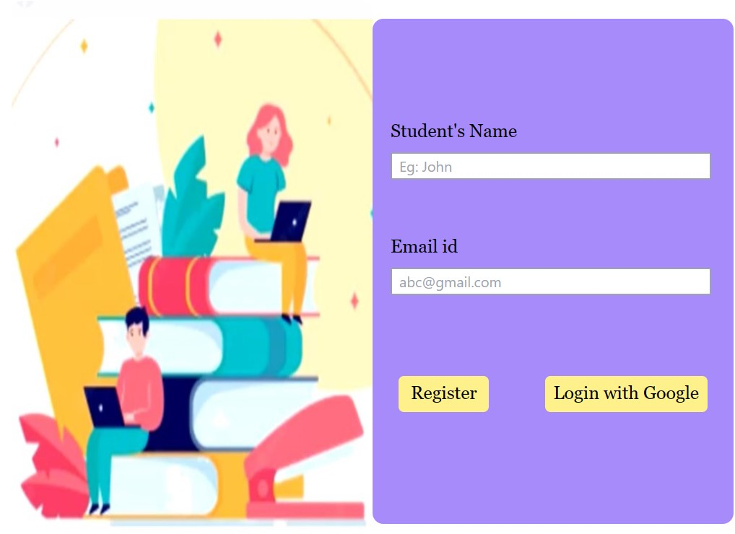

2)Homepage:

* Introduction to the platform's purpose and goals.
* A welcoming message and instructions for new users.
* Navigation options to other sections of the platform.

3)About Us:

* Information about the organization or entity behind the platform.
* Mission, vision, and objectives.
* Background and credibility.

4)Resources:

* Description of the aptitude testing process.
* Access to the testing interface or links to assessment tools.
* Instructions on how to interpret test results.

5)Detailed Career Paths:

* Comprehensive lists of different career paths and fields.
* Detailed profiles for each career path, including Job description and responsibilities and required education and skills.

2)Feedback and Reviews:

* Space for users to leave feedback and reviews about the platform.
* Testimonials from users who have benefited from the service.